**Deploying application on Tomcat using Eclipse**

1. Create Connection to Tomcat Server in Eclipse:

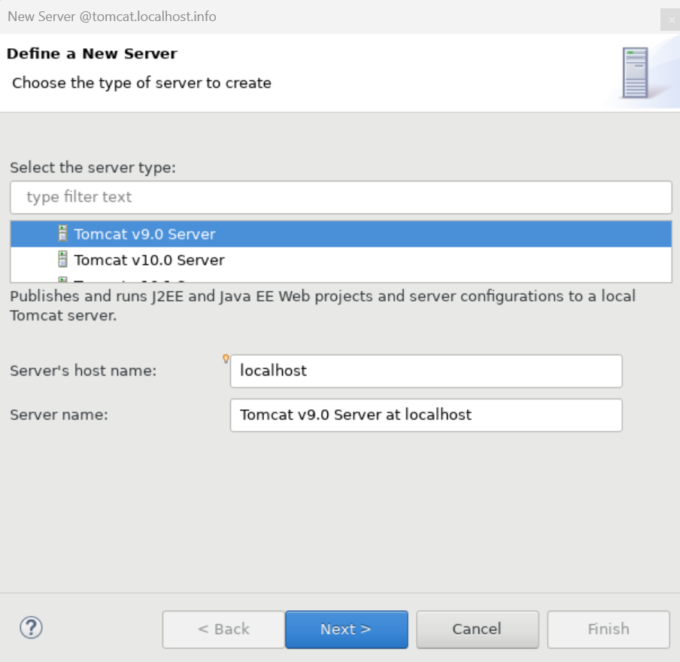

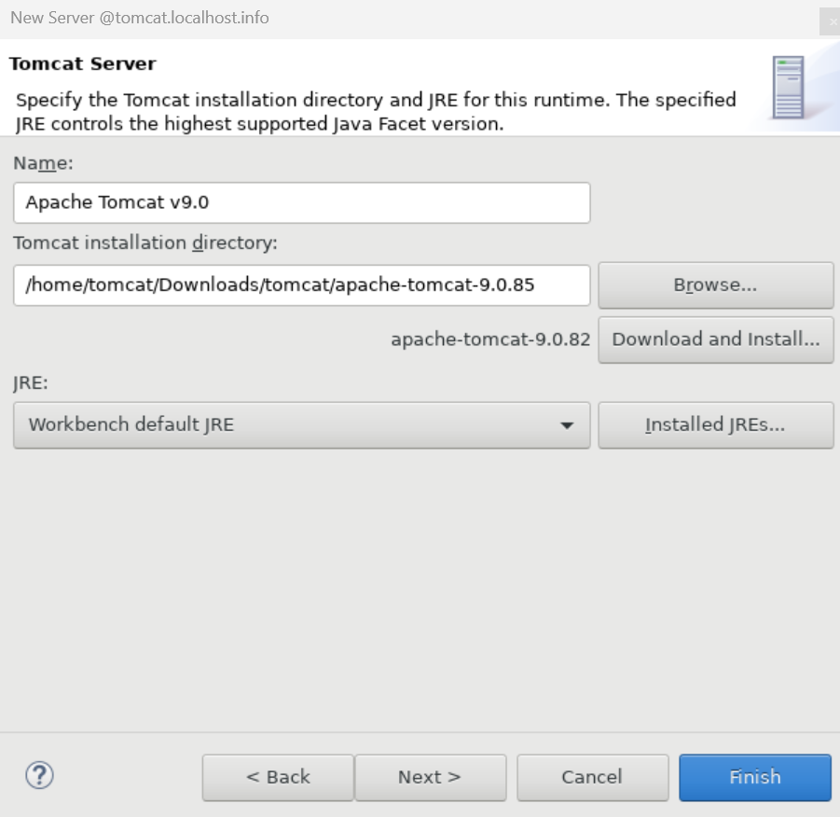

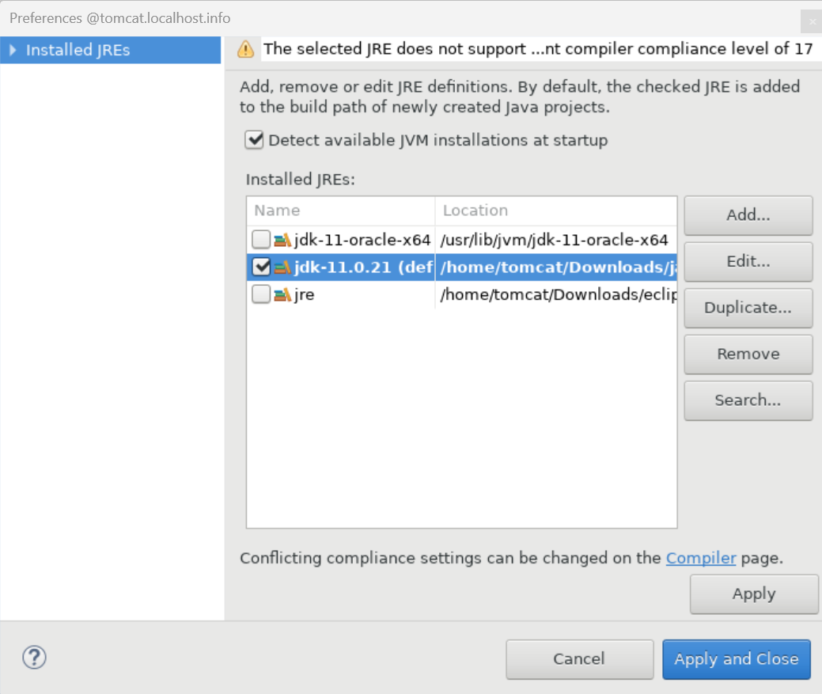

1. Start the tomcat Sever from Eclipse

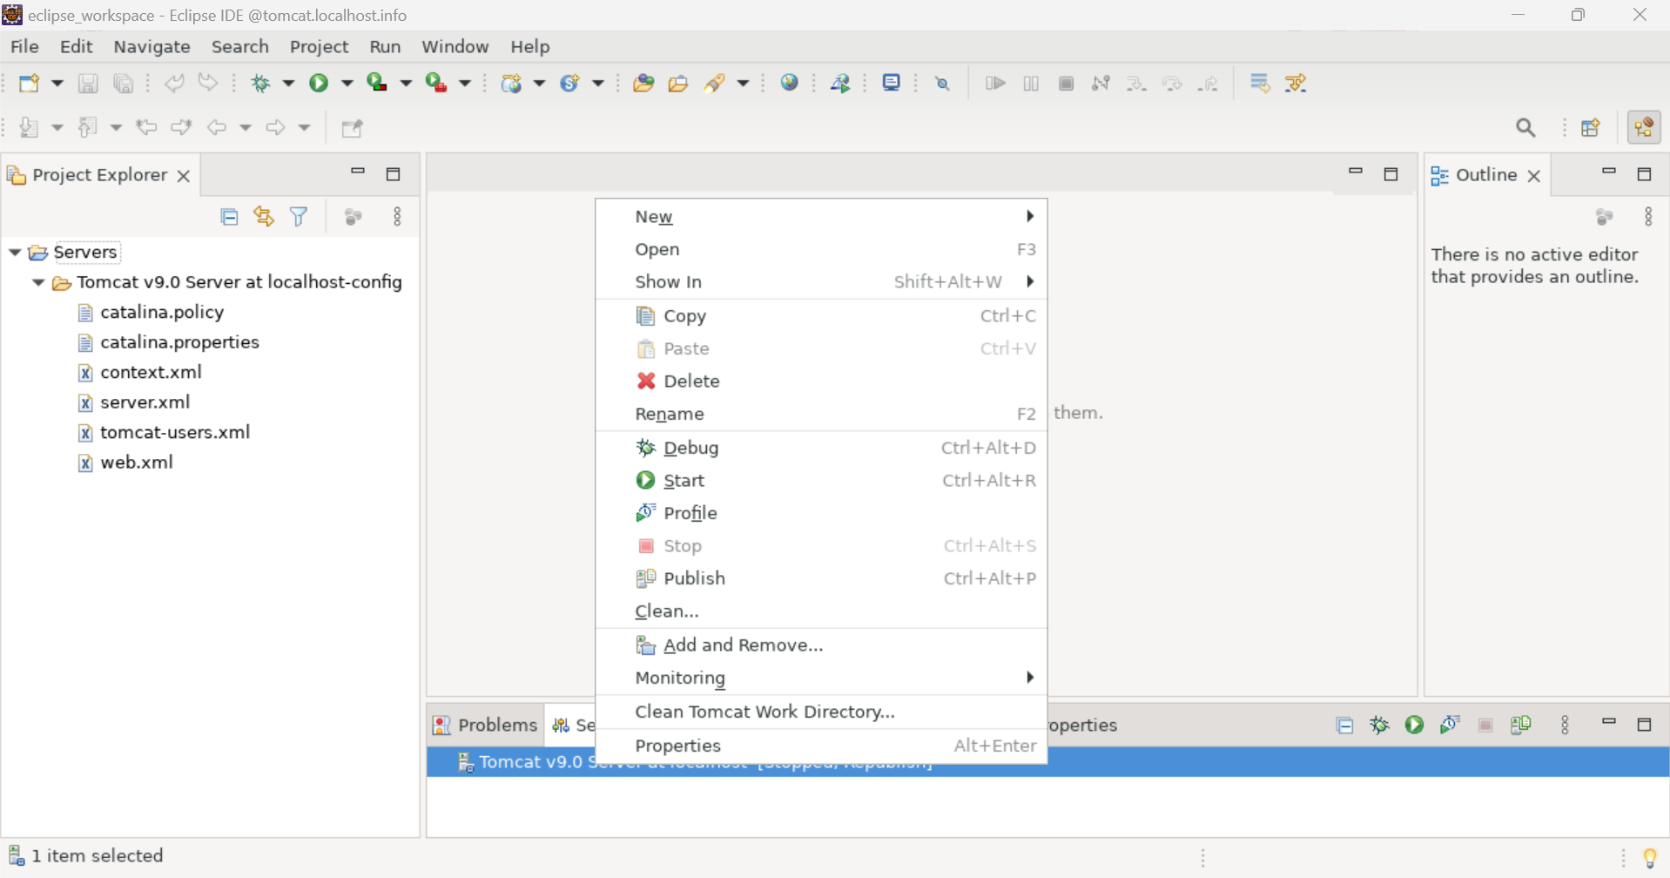



1. Double click on Server to change/view port config:

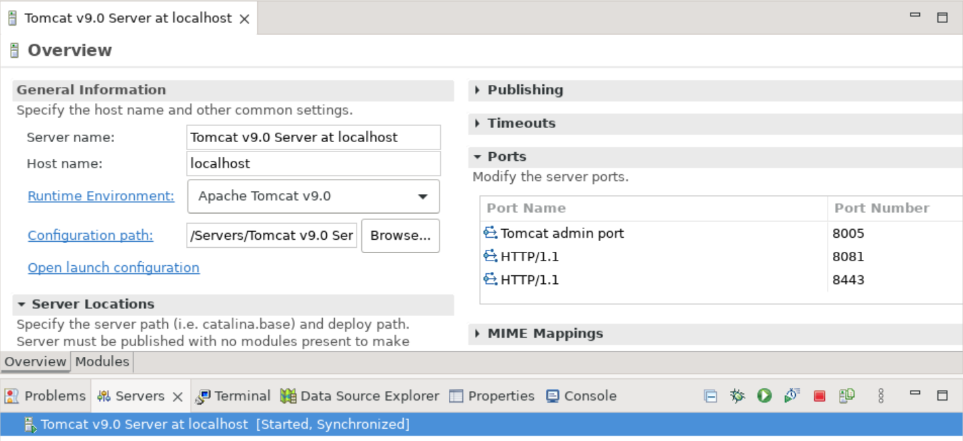

1. Right click and select New for Project creation: (I choose Dynamic web Project)

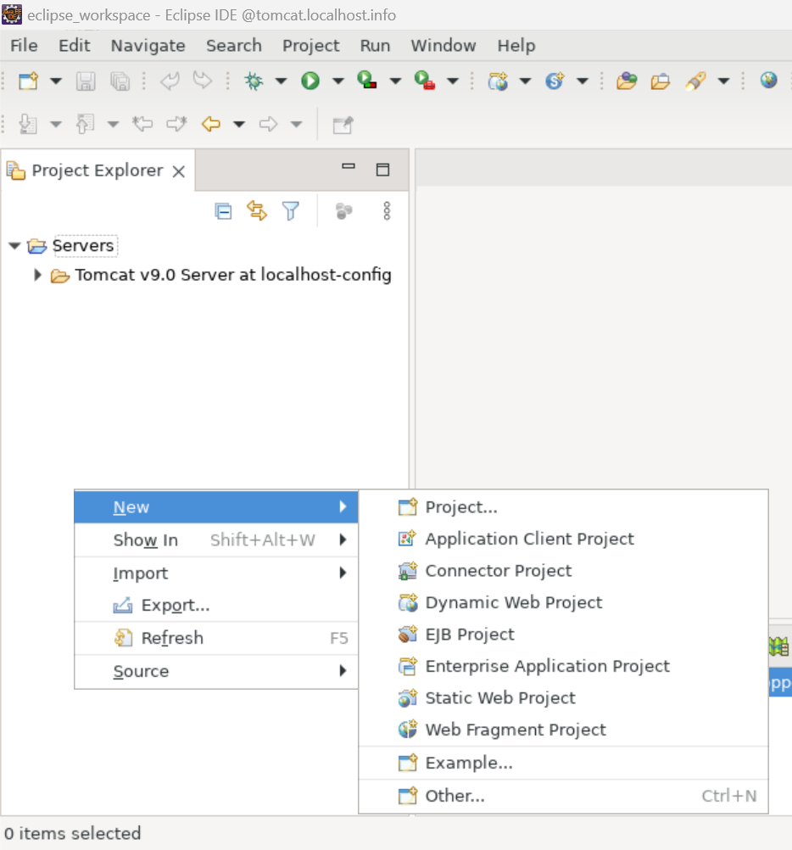

1. Select the type of project required and provide project name

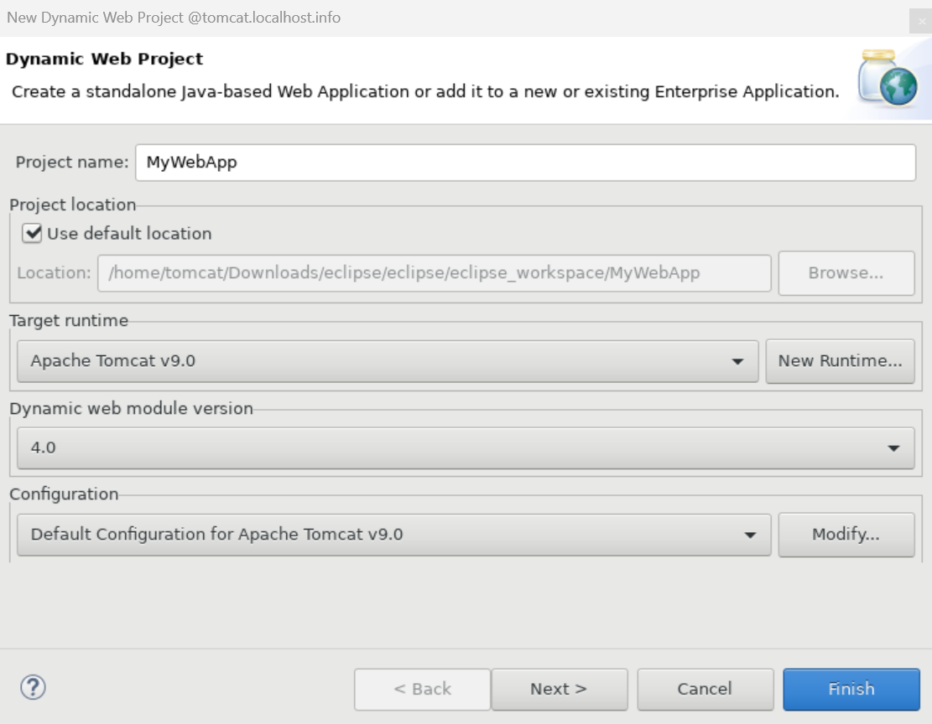

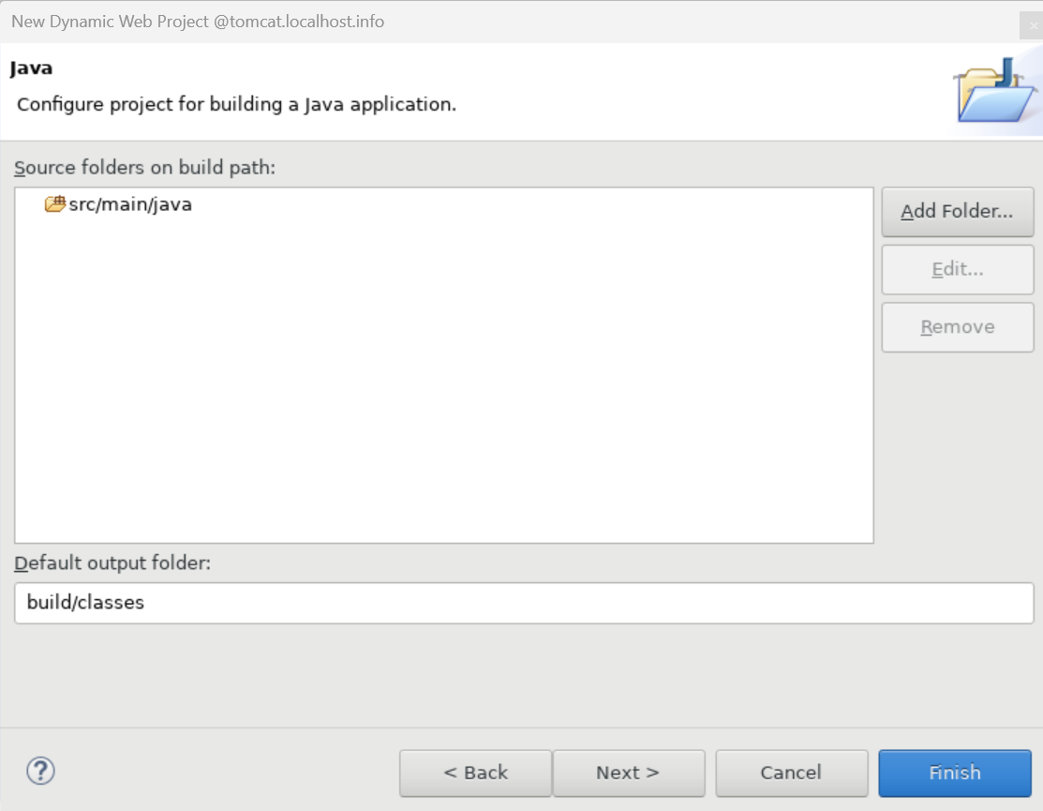

Provide Web Modules

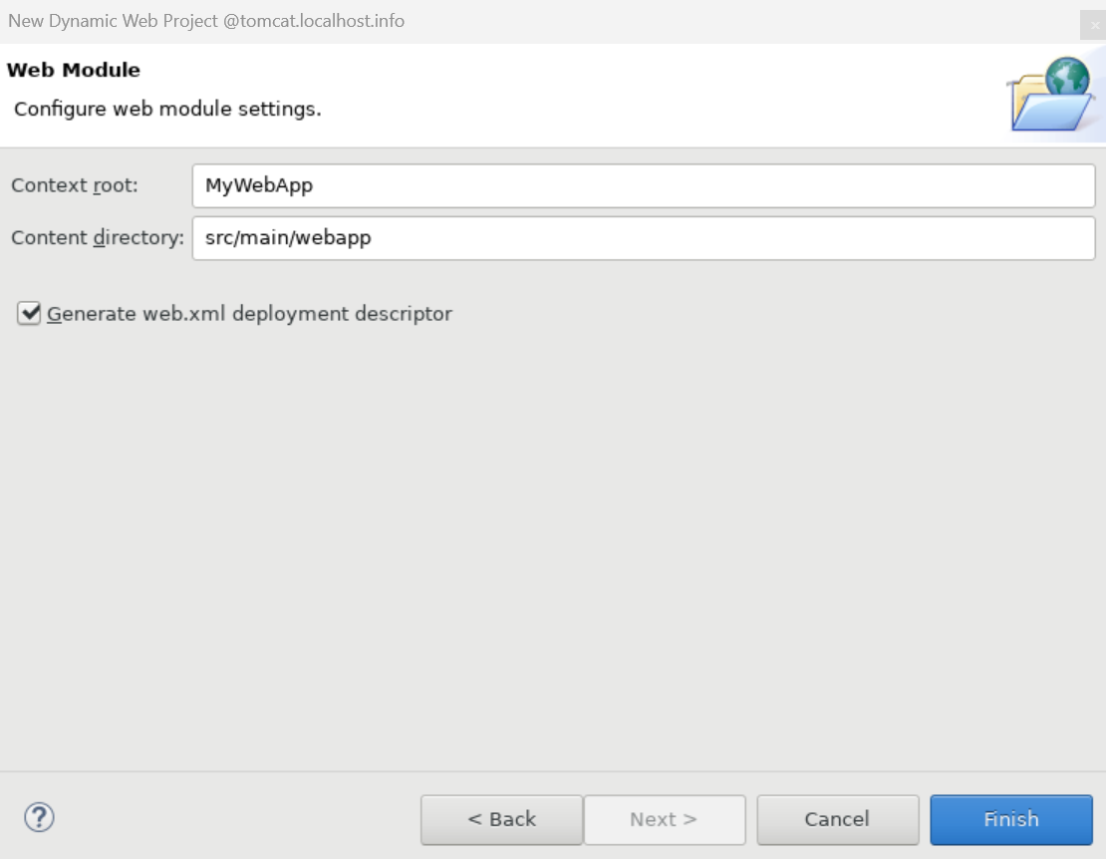

1. Project Directory Structure:

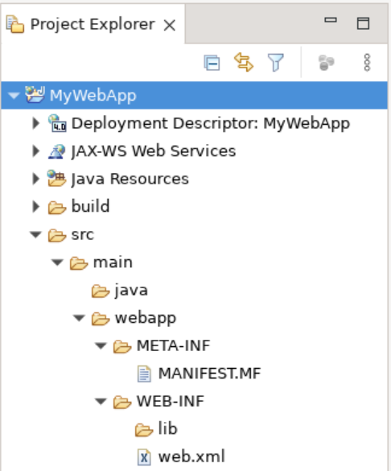

1. Right click on Webapp Directory and New, select type of file you create the web page. ( I choose JSP file)

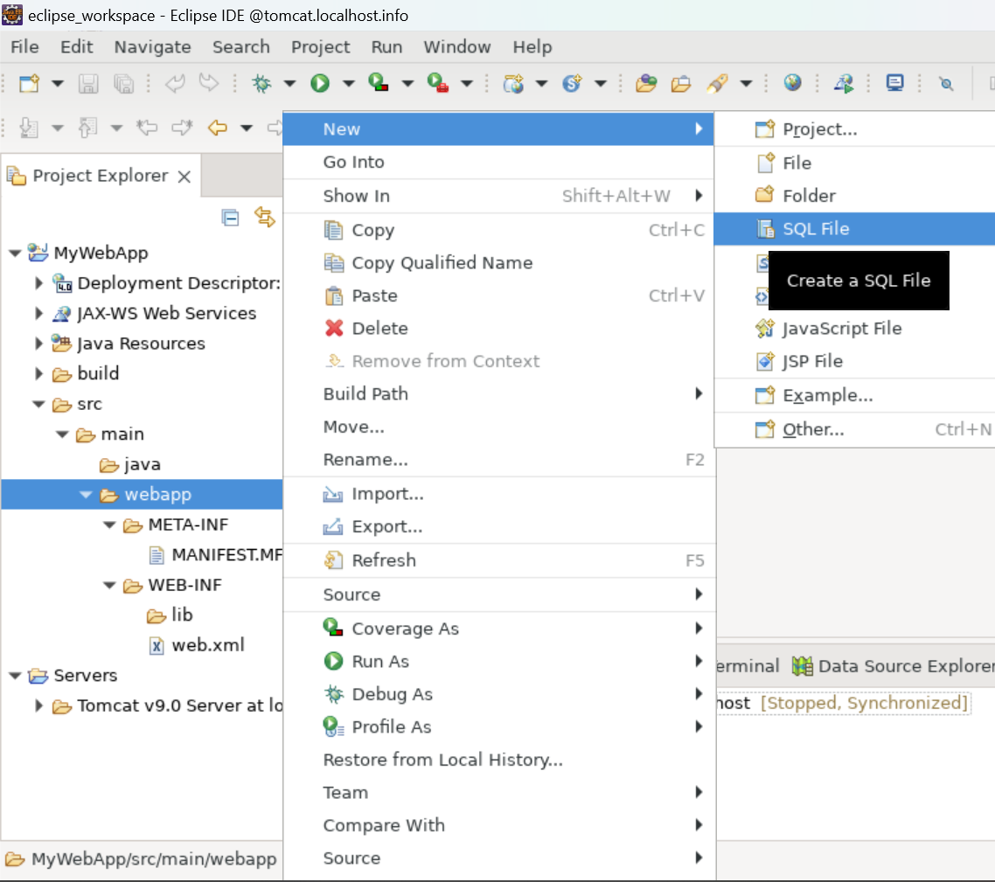

1. Provide file name and click next

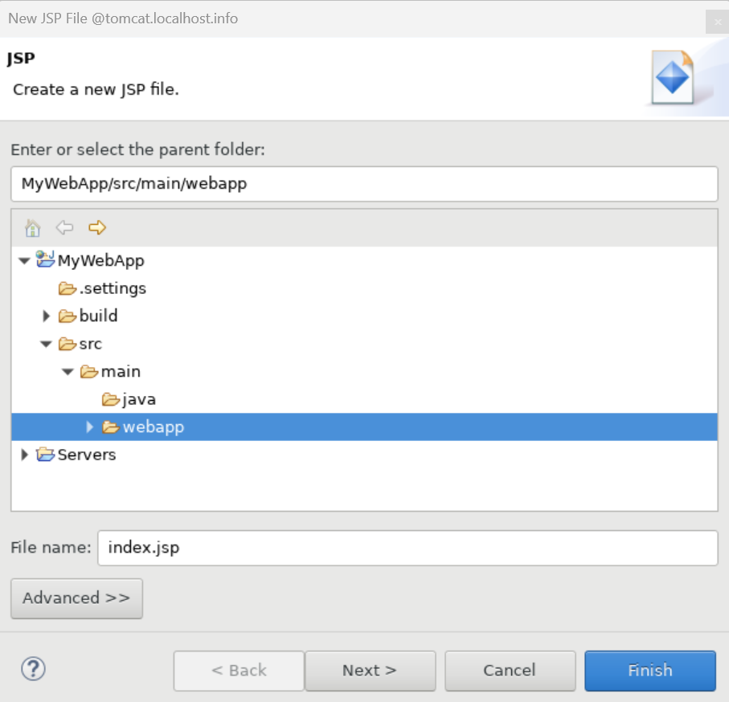

1. Select JSP template

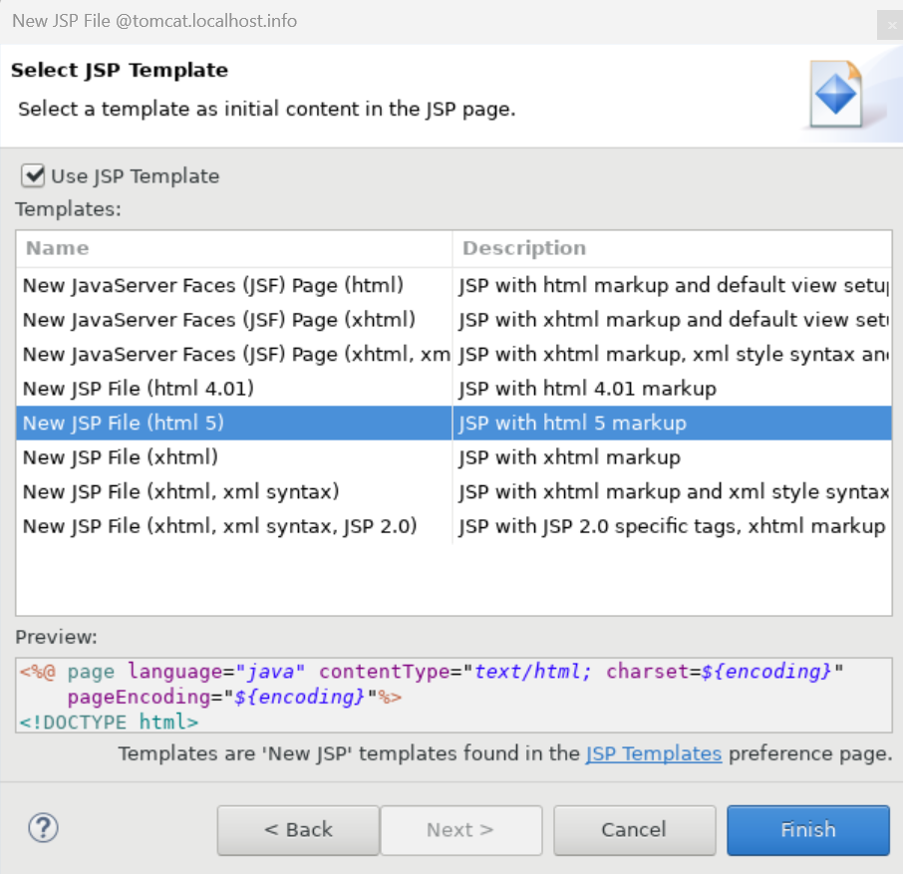

1. Write the jsp code needed for web application

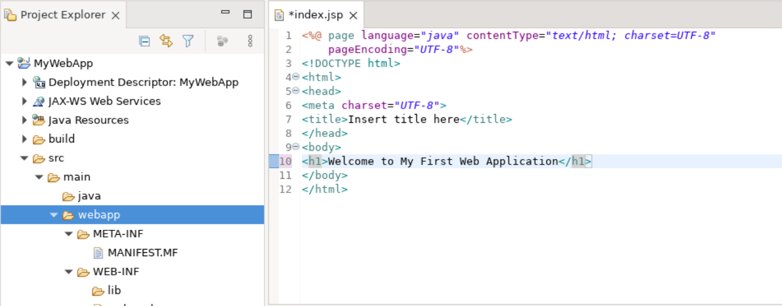

1. Deploy the Created Application on Tomcat Server.
2. Right click on server and select Add/Remove option.

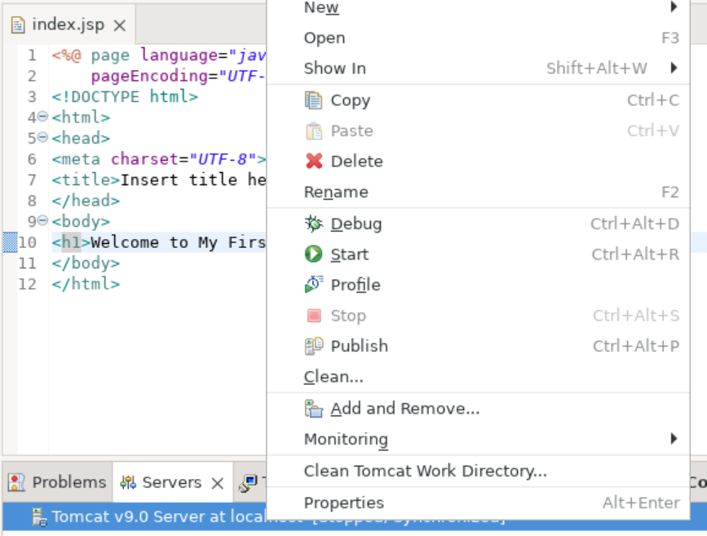

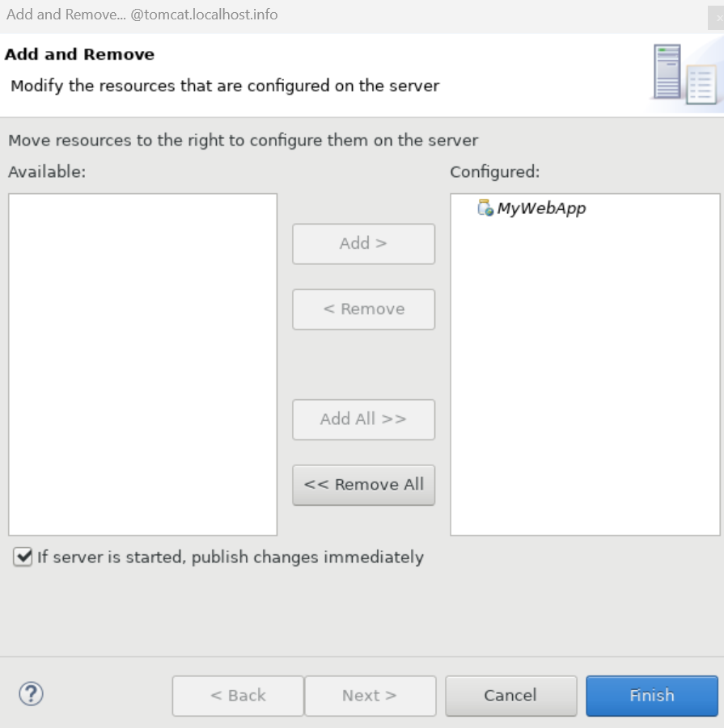

1. Start the Tomcat Server
2. Right click on web application and select Runs as than click Run on server to check web application deployment on eclipse. You can also check on browser.

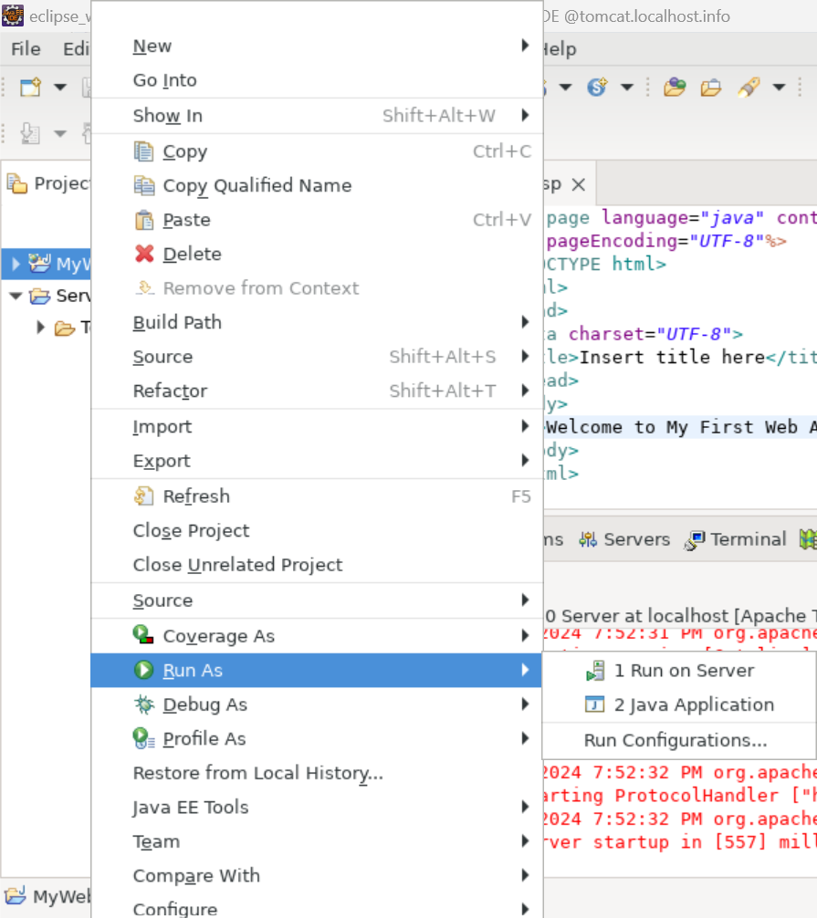

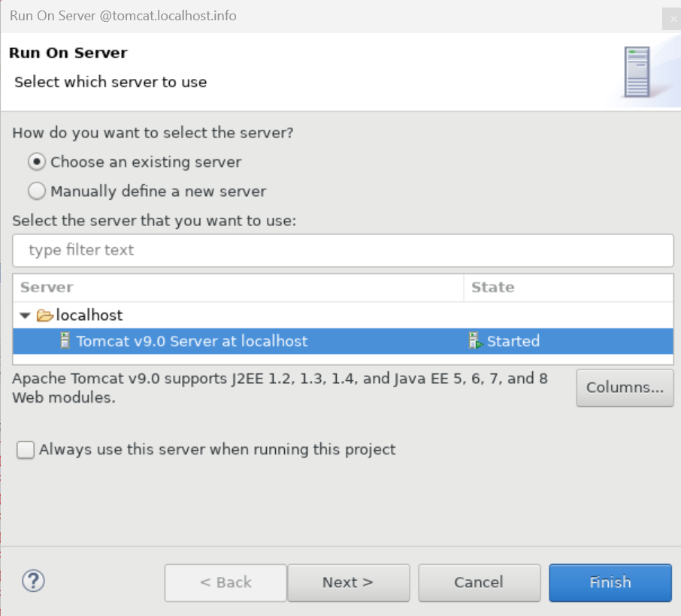

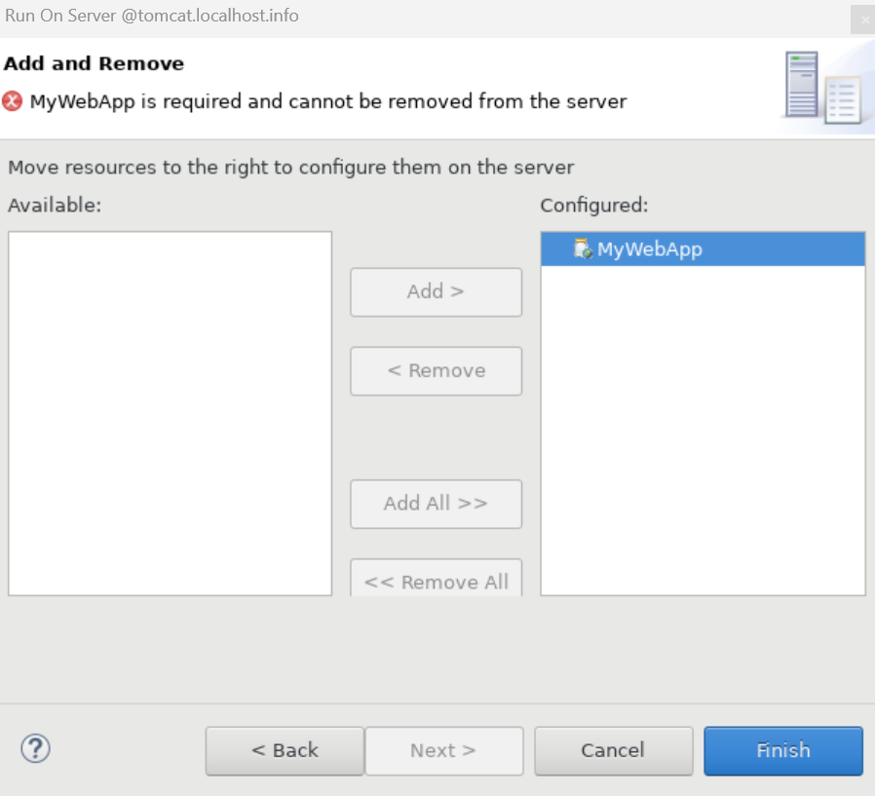

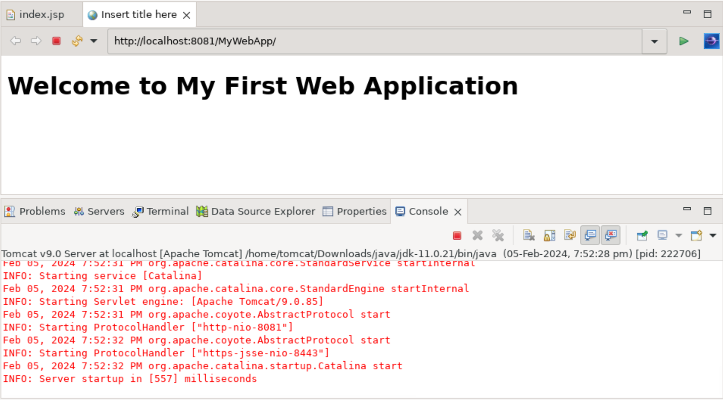

Link : http://localhost:8081/MyWebApp/

1. Successfully Deployed Web Application on Tomcat Server.